|  |  |  |  |
| --- | --- | --- | --- |
| 1 | | 31,200.0 | |
| NUMERO DE FRONTERAS | | ENERGIA AGREGADA | |
|  | | | |
| SI | | 04/09/2020 | |
| CONTRATO | | VENCIMIENTO CONTRATO | |
|  | | | |
| 57,863,927 | 109 | | 2,271,390 |
| INGRESO 2020 | DÍAS CERTIFICADOS 2020 | | ENERGIA RESPALDADA 2020 |
|  | | | |
| 102,442,827 | 142 | | 4,427,801 |
| INGRESO 2021 | DÍAS CERTIFICADOS 2021 | | ENERGIA RESPALDADA 2021 |

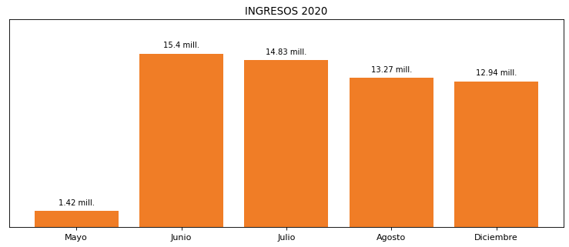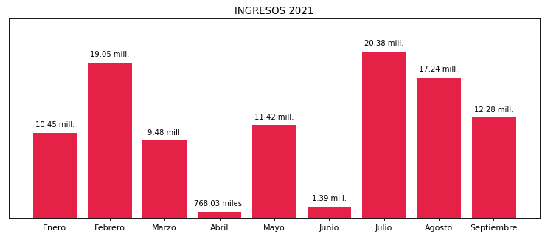

|  |
| --- |
| **ESTELAR CARTAGENA DE INDIAS**  USUARIO |

|  |
| --- |
| **Mateo Porras**  Ejecutivo de cuenta |

|  |
| --- |
| **Jorge Alfonso Millán Guevara / Gerente Corporativo de Soporte Técnico / jorgea.millan@hotelesestelar.com**  Primera fecha: PUNTO FOCAL |

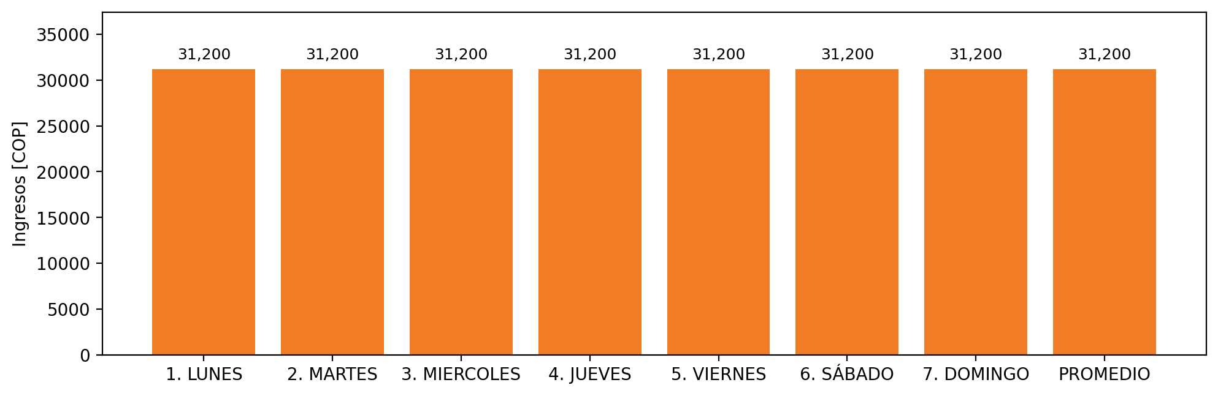

|  |  |  |  |  |  |  |  |  |  |
| --- | --- | --- | --- | --- | --- | --- | --- | --- | --- |
| **FRONTERA COMERCIAL** | **TIPO DDV** | **COD SIC** | **PREDIO** | **PROMEDIO** | **MARGEN** | **ÚLTIMA DESCONEXION** | **DÍAS CERTIFICADOS** | **ACTUALIZACION** | **PROXIMA PRUEBA DDV** |
| HOTEL ESTELAR CARTAGENA DE INDIAS | Frt36998 | Frt26708 | Prd01699 | 31,200 | NO APLICA | 2021-06-15 | 72.0 | 2023-04-15 | 2021-11-30 |